Experiment-4
Aim
To implement histogram equalization on a given image using OpenCV and compare the histogram-equalized image with the original image.
Procedure
- Import the OpenCV and Matplotlib libraries.
- Read the input image.
- Convert the image into gray-scale.
- Apply histogram equalization using cv2.equalizeHist().
- Display the original gray-scale image and equalized image.
- Calculate and display their histograms.
- Compare the contrast of both images.
Code
import cv2
import matplotlib.pyplot as plt

# Read the image
img = cv2.imread r"C:\Users\VARSHINI\Downloads\sample image.png"
)

# Convert to grayscale
gray = cv2.cvtColor(img, cv2.COLOR_BGR2GRAY)

# Apply histogram equalization
equalized = cv2.equalizeHist(gray)

# Display images
plt.figure(figsize=(10, 6))

plt.subplot(2, 2, 1)
plt.imshow(gray, cmap="gray")
plt.title("Original Image")
plt.axis("off")

plt.subplot(2, 2, 2)
plt.imshow(equalized, cmap="gray")
plt.title("Equalized Image")
plt.axis("off")

# Original histogram
plt.subplot(2, 2, 3)
plt.hist(gray.ravel(), 256, [0, 256])
plt.title("Original Histogram")

# Equalized histogram
plt.subplot(2, 2, 4)
plt.hist(equalized.ravel(), 256, [0, 256])
plt.title("Equalized Histogram")

plt.tight_layout()
plt.show()
Sample Input
Input: sample image.jpeg — a grayscale-convertible color image.
Sample Output
The output contains four parts:
- Original Image – original gray-scale image.
- Equalized Image – image with improved contrast.
- Original Histogram – intensity distribution before equalization.
- Equalized Histogram – intensity distribution after equalization.
Comparison
Original Image | Histogram Equalized Image
Normal contrast | Improved contrast
Original intensity distribution | More distributed intensity levels
Histogram may be concentrated in a smaller range | Histogram is generally spread over a wider range
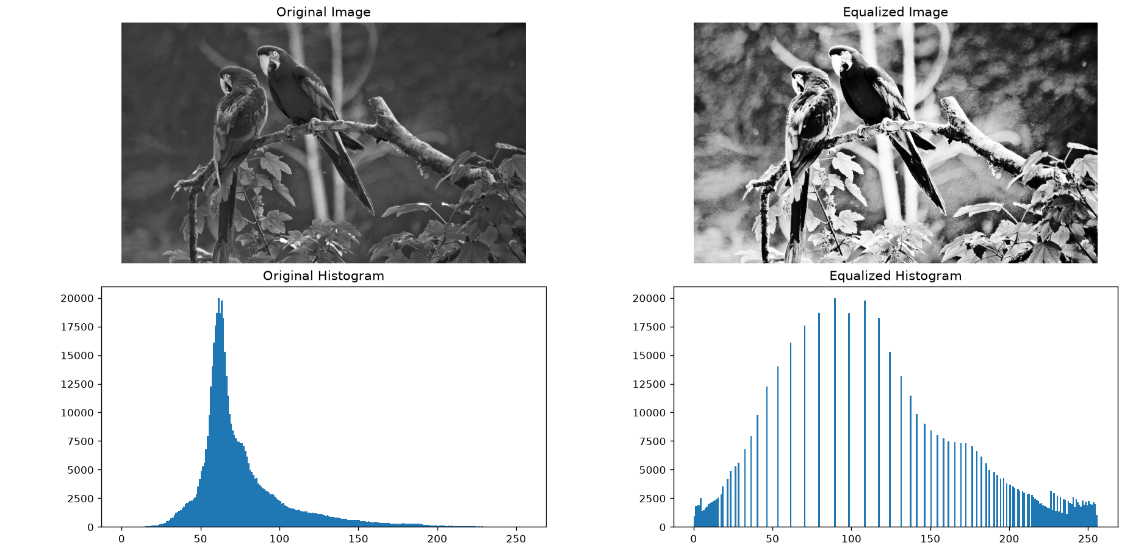

Result
Thus, histogram equalization was successfully implemented using OpenCV. The equalized image showed improved contrast compared with the original gray-scale image.

